Index Search Installation & Configuration on Windchill 13.0 - RH1
Schindler CRD Applications

Exported on 2025-08-19 05:08:10

Table of Contents

1 Prerequisite: 4
2 Index Search Installation Process: 5
3 Index Search Configuration: 10
4 Index Search as Windows Service: 12
5 Bulk Indexing: 13

- Prerequisite:
- Index Search Installation Process:
- Index Search Configuration:
- Index Search as Windows Service:
- Bulk Indexing:

Prerequisite:
- Need Administrator access on the Target server.

Index Search Installation Process:
- Download and extract both PSI and Index Search installable to same folder.
- Run command prompt as administrator and make the load point to PSI and execute setup.vbs as shown below.
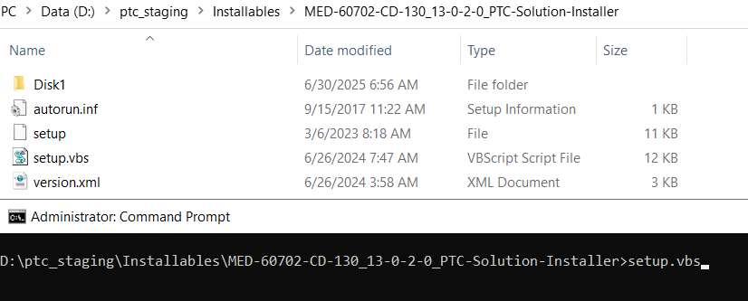 f

3. Click on Ok.
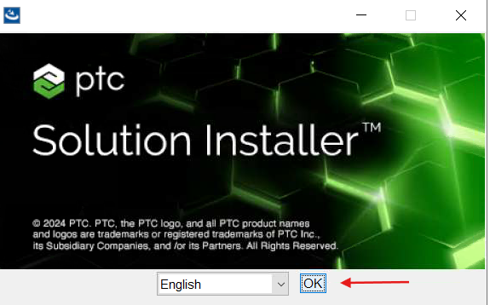

4. Click on Next.
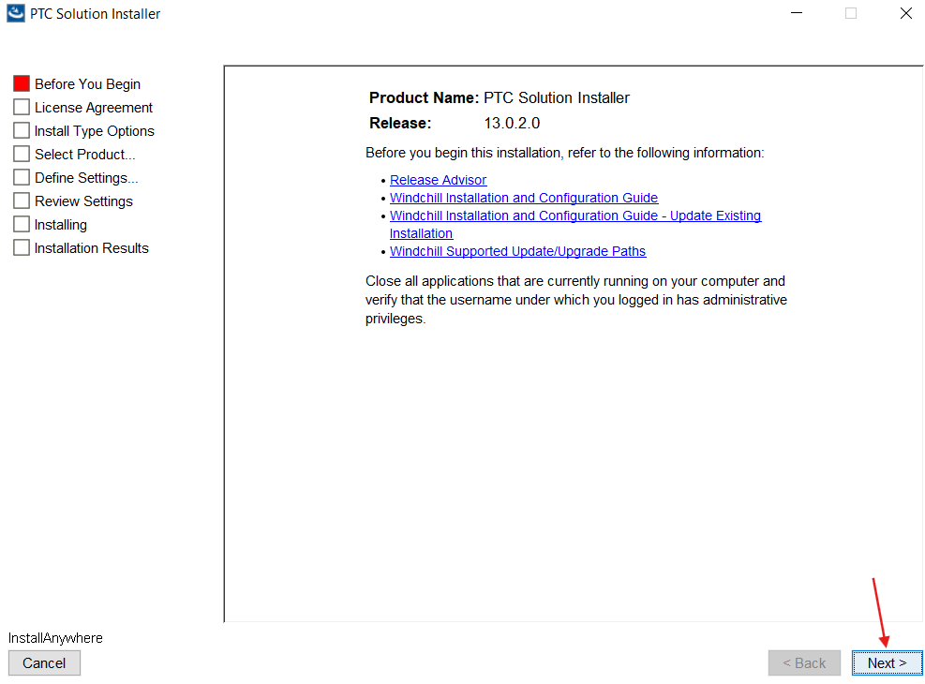

5. Select 'I accept' and click on Next.
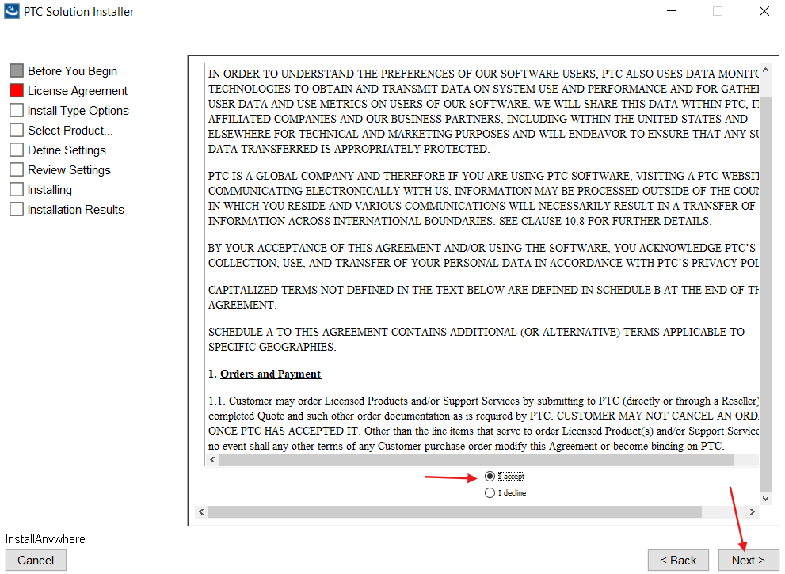

6. Select 'I have read the above statement' and click on Next.
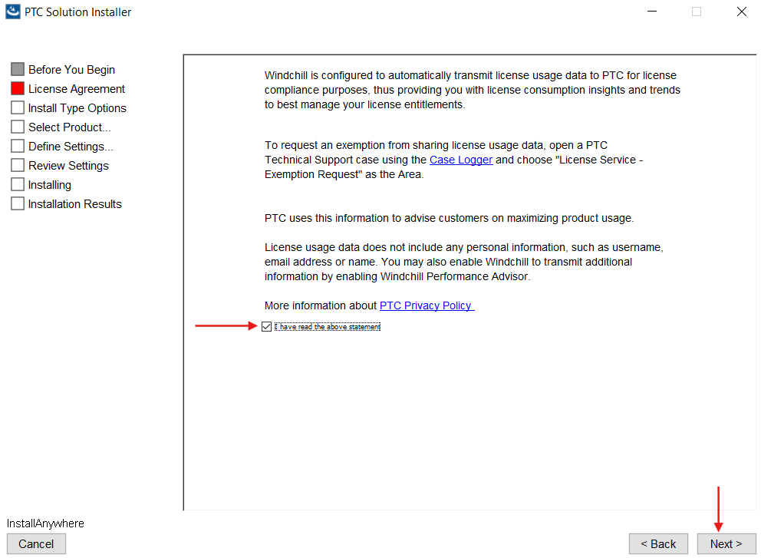

7. Select 'New Product Installation' and click on Next.
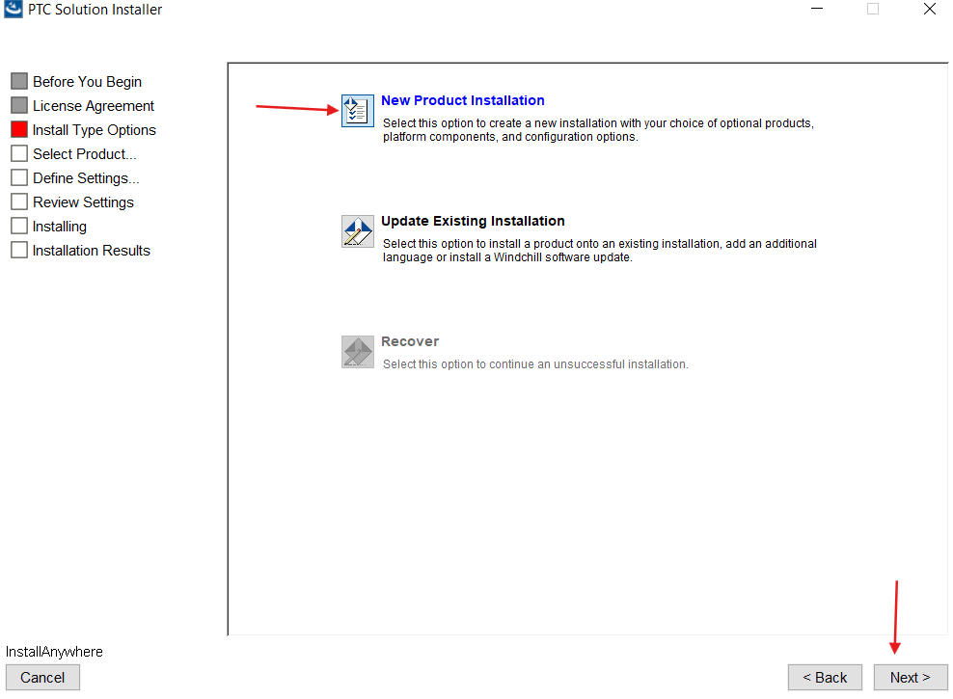

8. Select 'Standalone Product or Component' and click on Next.
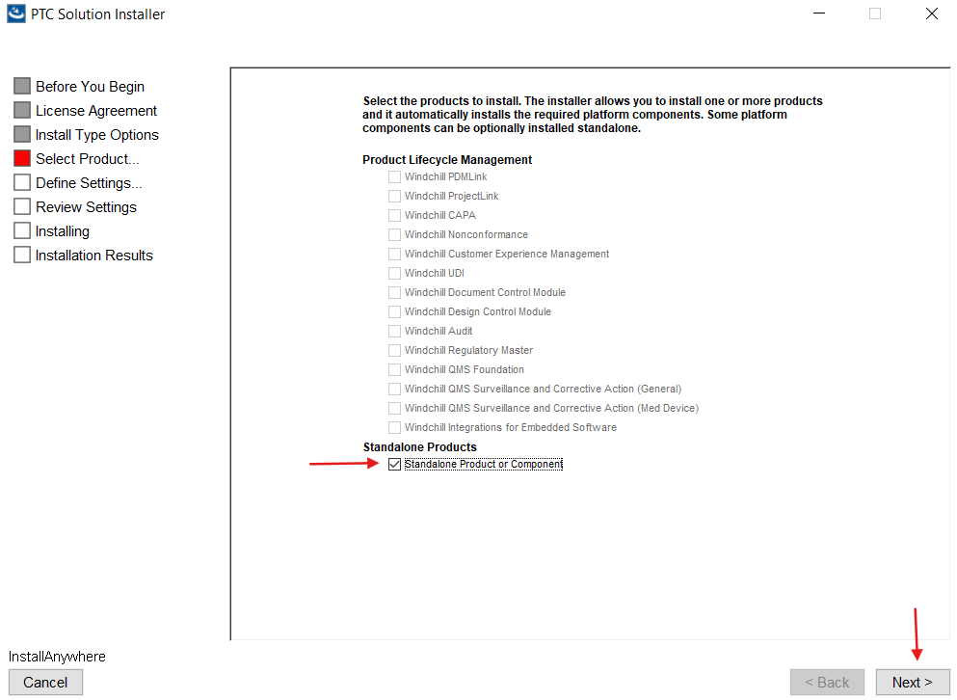

9. Select 'Windchill Index Search Server' and click on Next.
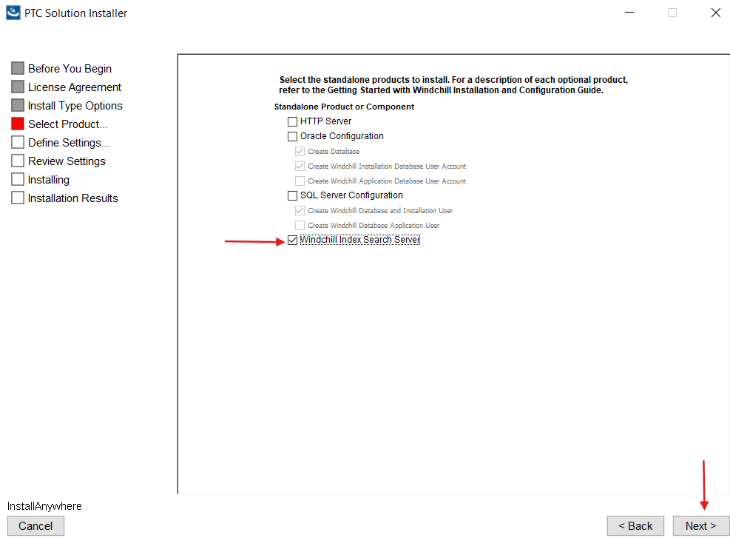

10. Provide Installation Name as shown below and click on Next.
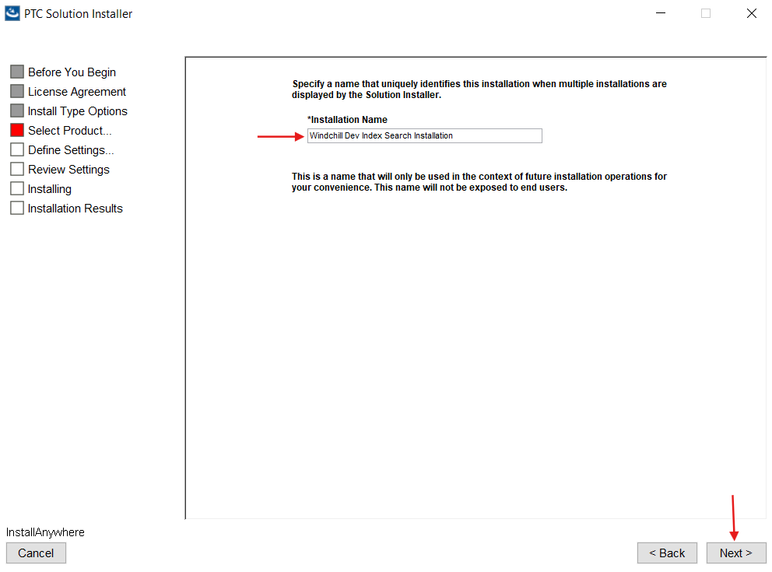

11. Update the Installation directories as shown below and click on Next.
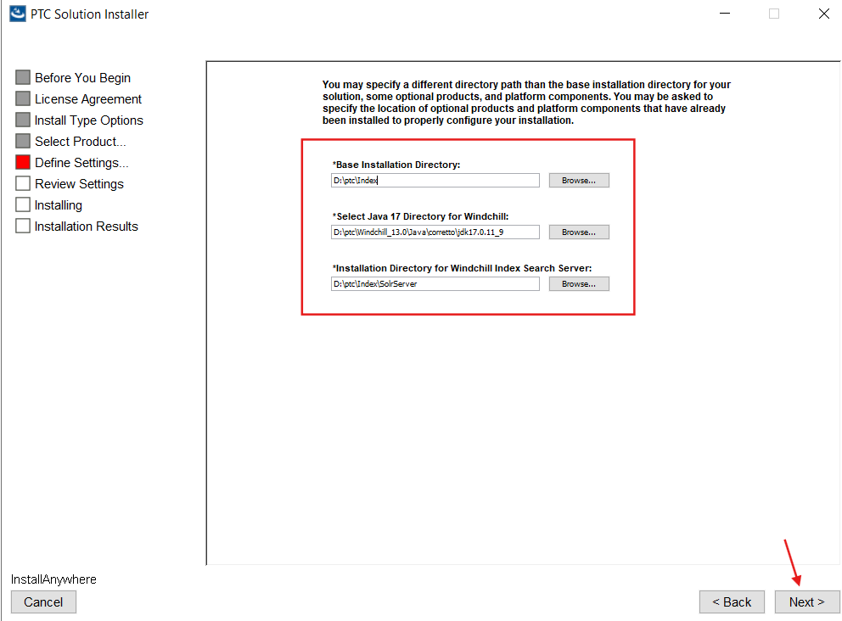

12. Provide the details as shown below and click on Next.
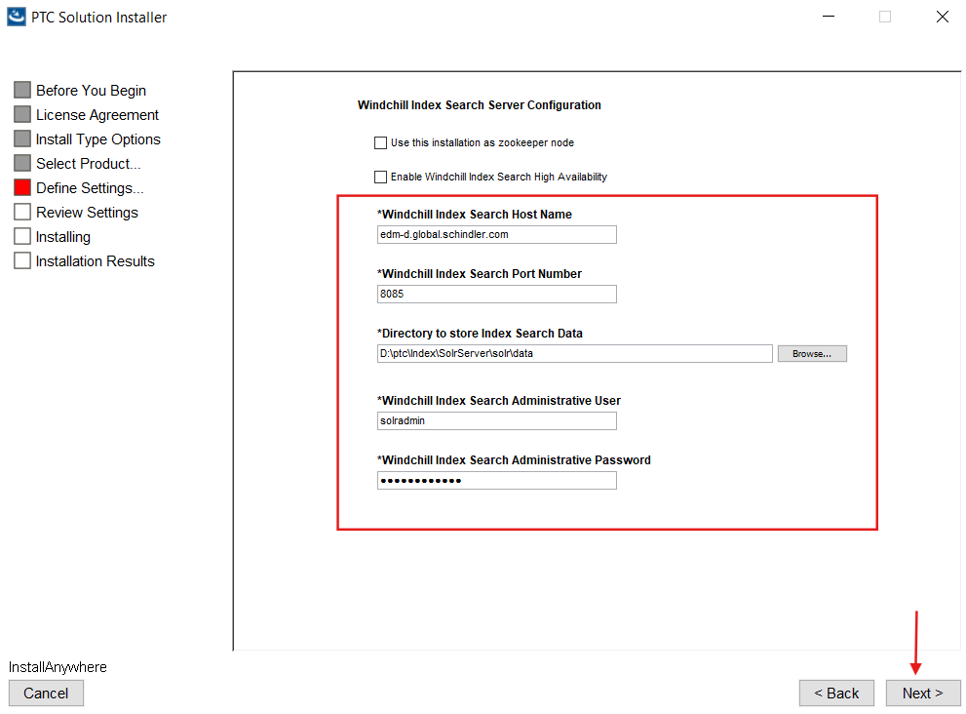

13. Click on Next.
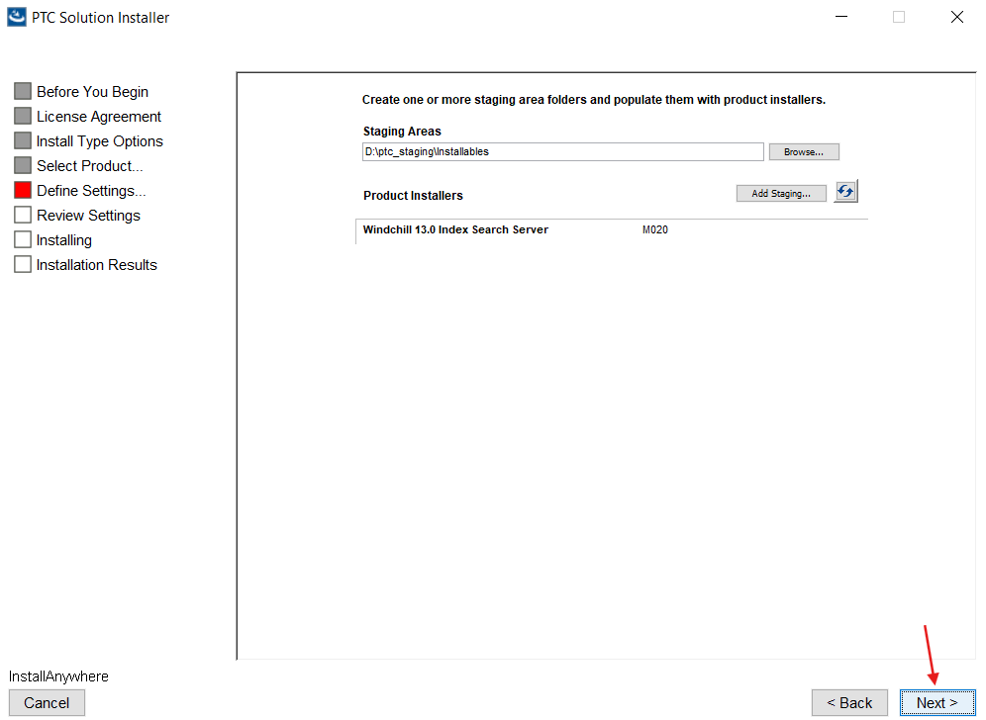

14. Click on Install.
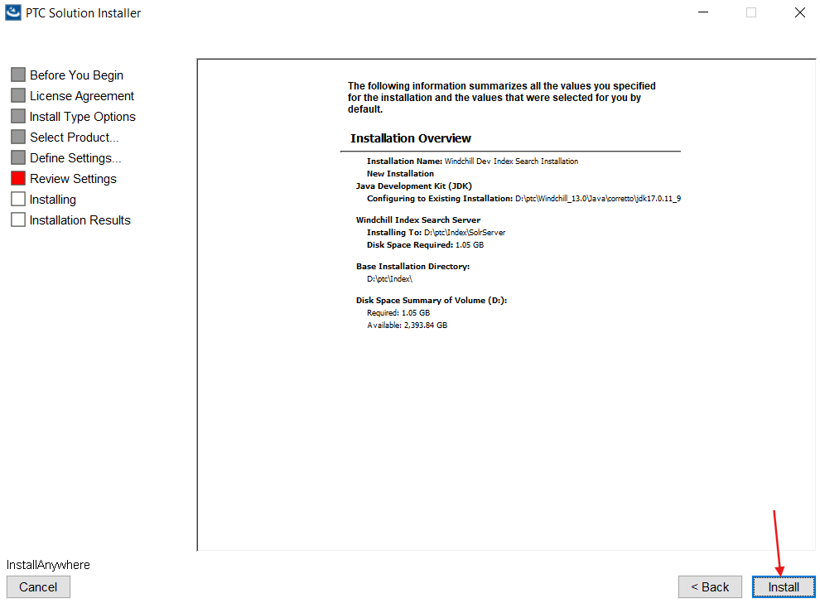

15. Click on Done.
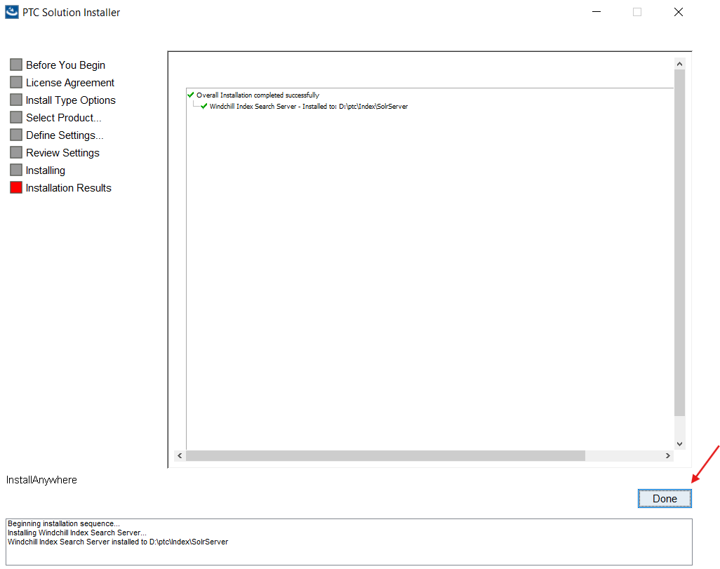

Index Search Configuration:
- Verify below properties are available as per the screenshot under <WT_Home>/codebase/wt.properties.
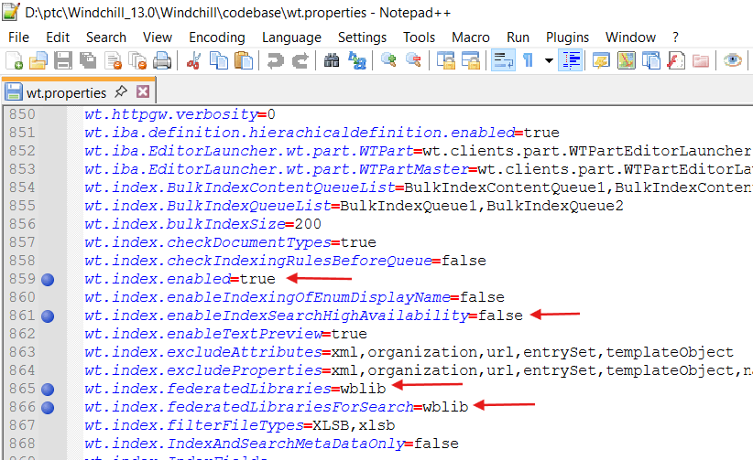
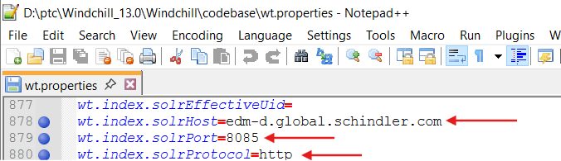

2. Open the index.solrAuth.properties file located at <WT_Home>/codebase/WEB-INF/conf folder and verify the below properties are available.
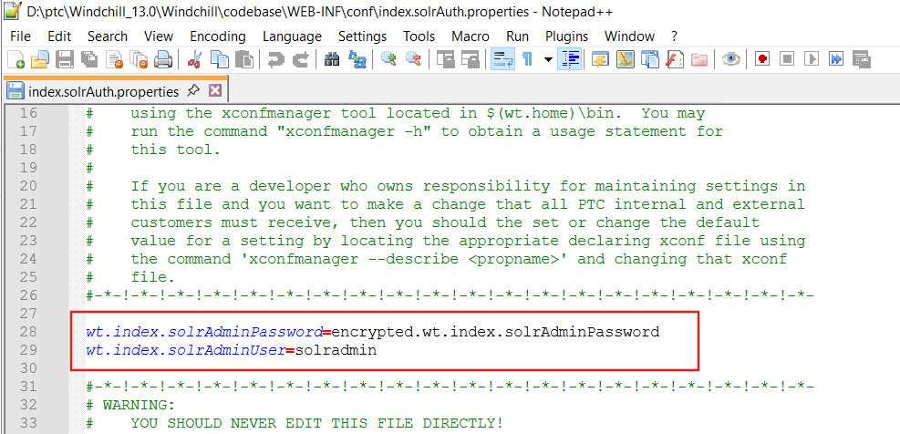
3. Open the solrserver.properties file located under 'D:\ptc\Index\SolrServer\config\solrserver.properties' and verify the below properties are available.
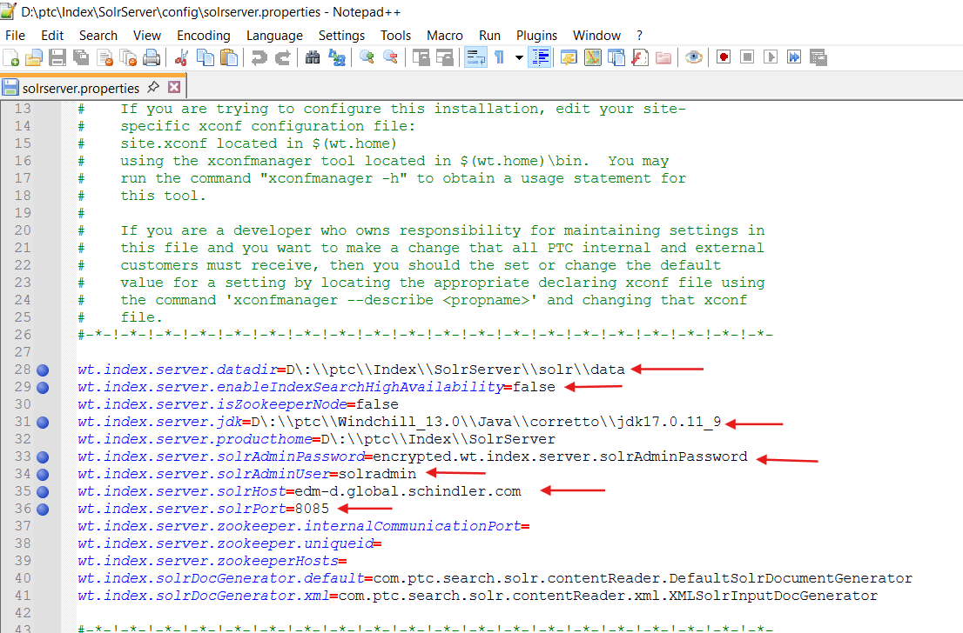
4. Launch command prompt as administrator and make load point as 'D:\ptc\Index\SolrServer\bin' and execute below command to start the Index Search.
Index_Search_Server.bat Start


Index Search as Windows Service:
- Launch Windchill Shell as an admin and navigate to <Index_Search_Home>/bin and install_solr_service.bat as shown below.
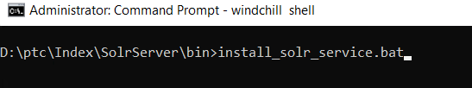

2. Make sure it is installed successfully.
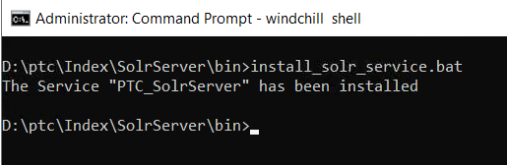

3. Verify PTC_Solr service is added to Windows service.
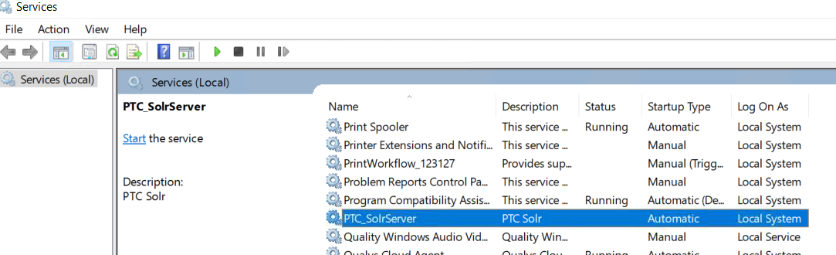

Bulk Indexing:
- Start Solr, Apache, DS and Windchill.
- Log into Windchill as Administrator.
- Navigate to site → Utilities → Indexing Administration → click on 'Delete the bulk indexing list of objects'.
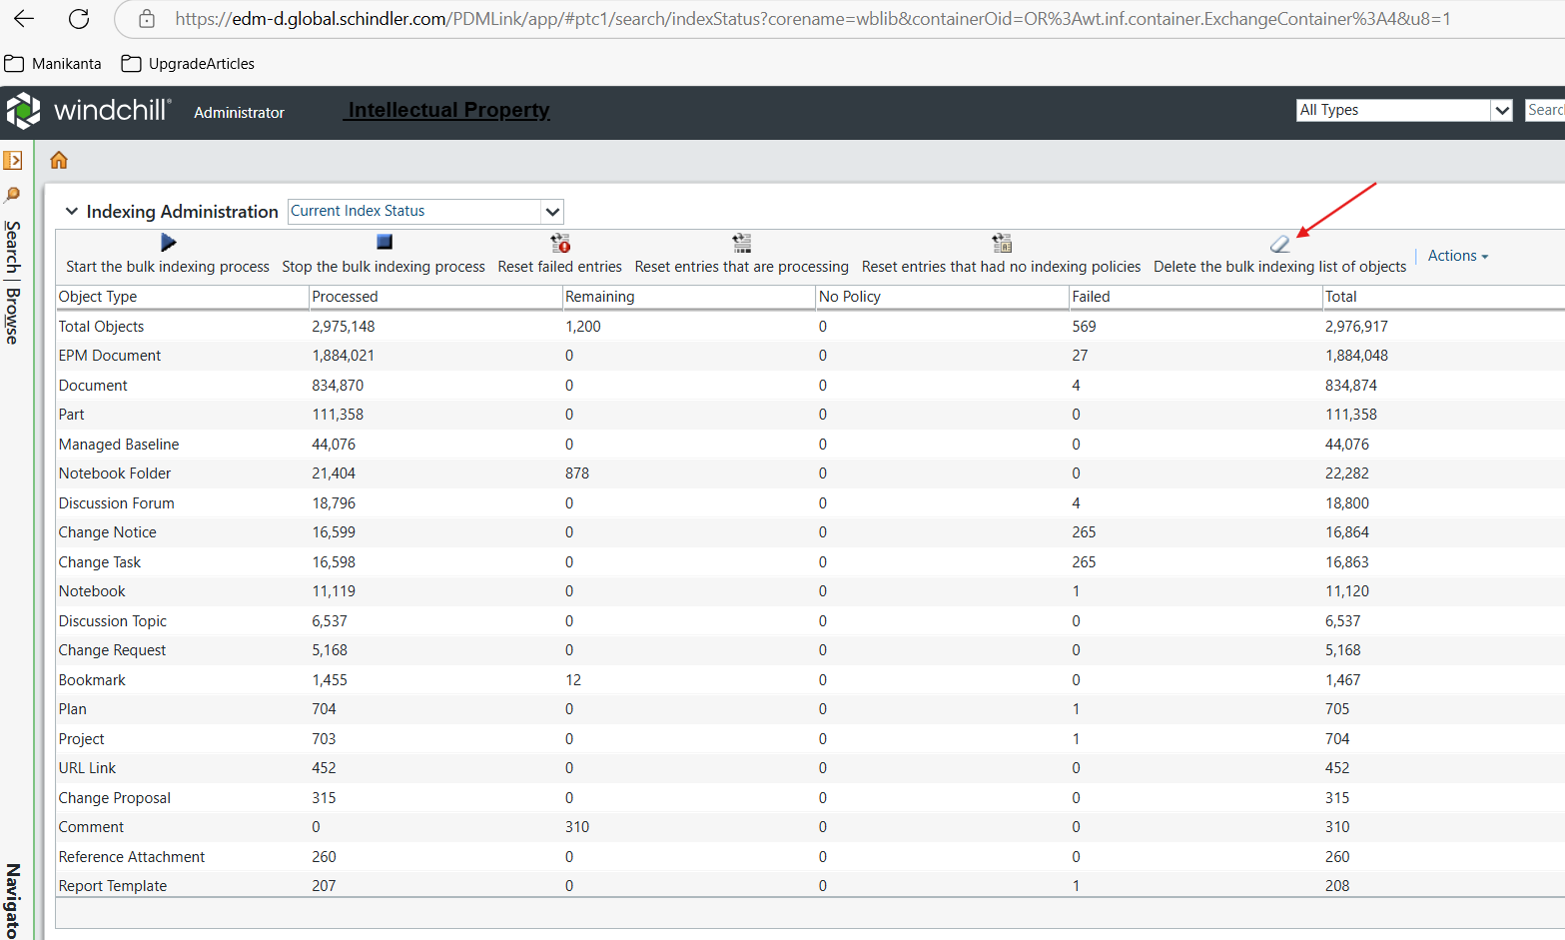

4. Click on Ok.
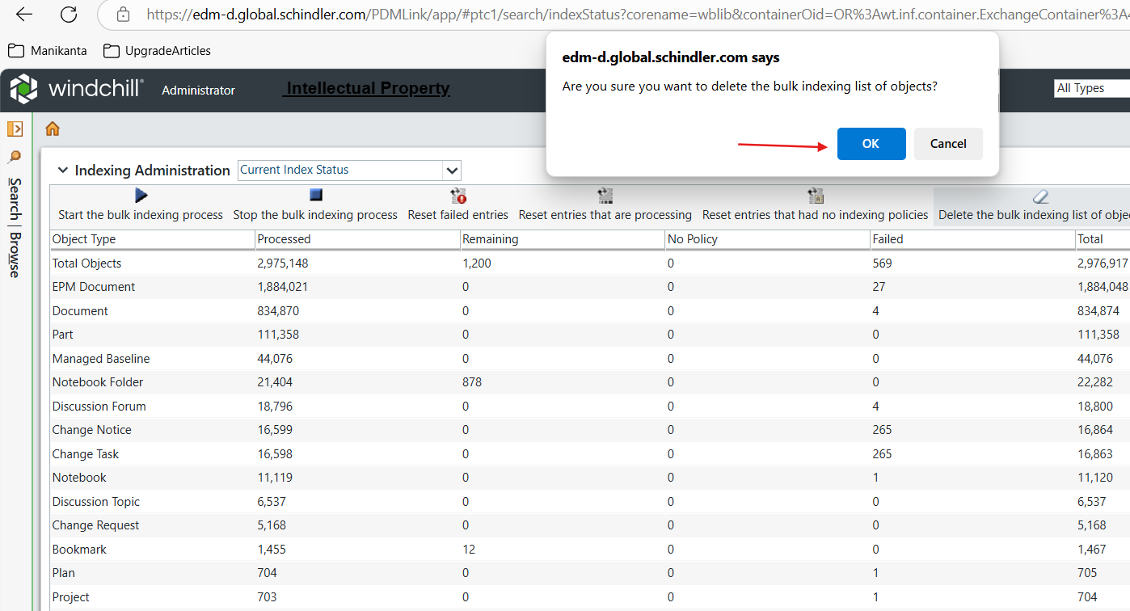

5. Click on Start Bulk Indexing as shown below.
